# VA Mobile App Discovery: Usability Testing Report

## Background

We performed a series of four usability tests with Veterans to help inform the vision for a VA mobile app. This study allowed us to gain an initial understanding of Veteran’s expectations for a mobile experience that meets their needs. While these findings helped us develop some initial assumptions, we also see areas of opportunity to go deeper in our mobile research with Veterans.

## Method: Usability testing

Over the course of two days (March 18 - 19, 2020), we performed a series of 45 minute usability testing sessions with four Veterans. These sessions walked participants through a clickable prototype of an initial VA Mobile prototype.

During these sessions, each participant clicked through 16 screens representing interactions with a VA mobile app. They were told that, for the purposes of this study, they would be pretending to be a person named Kim Washington who looked at their VA Mobile app on their iPhone

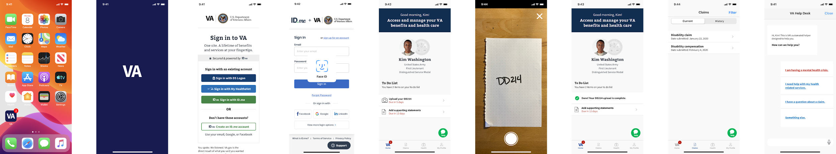

The initial screen was a home screen that included a VA logo. Veterans were asked what they thought that this screen was asking them to do and what their next steps would be, see Appendix.

### Participant Demographics

* All participants were Veterans.
* 2 female, 2 male participants.
* Age range between 32 - 85 years old.
* 3 States represented between participants.
* All participants owned a smartphone.
* 3 participants had an iPhone, 1 participant had an Android phone.

## Themes

Below are a few overarching themes that we uncovered from this research. Under each theme you will see observations and/or direct quotes from participants that fall under this particular theme.

### All participants felt comfortable using biometrics (Face ID, thumbprint) to log in to a VA Mobile experience.

“It’s like a 50/50 chance that it [cloud based log in] will actually work, but Face ID is really dependable.” - P2

“That sounds like it would be nice and easy. Especially for older people this would be helpful.” - P4

### All participants stated that a VA Mobile App would make it easier for them to connect to VA staff about their VA related services.

“When you talk to an actual human, it's more personal and you can ask your specific question.” - P1

“It’s nice to have the immediacy, I always have my phone with me. I like having the ability to access certain things, like mental health. If I’m out somewhere having a panic attack, I am not going to be able to get back to my computer. It’s the one thing that stays with me all the time. Certainly, anything that has an immediacy component, I would really like to see her.” - P2

“I would expect to see a way to talk to my doctor with questions.” - P4

“I would expect to be able to talk to my doctor, or send an email to my doctor.” - P3

### Most Veterans stated that they would expect to see a personalized experience when initially logging in to a VA Mobile experience.

As mentioned earlier in the report, we asked Veterans what they expected to see when initially logging in to their VA Mobile application. We had varied results in their expectations, from health related services, to GI Bill data, to the ability to check on what discounts were available to them as a Veteran, and know that a personalized experience would best meet all Veterans direct needs.

“I would hope to see a master menu that would let me see the choices for this app.” - P2

“I would expect to see the actual different parts of the website. Click here to go there, or whatever.” - P1

“There’s nothing else that’s told me so far within the app, so I expect something that tells me a menu of things I can do.” - P4

“It's critical that it’s intuitive and easy to use. I know that’s hard! When you hold conversations with people like me. It’s good to be clear about the desired purpose of the app, then it can help me formulate reposense.” - P4

## Next Steps

Below are a set of recommendations to inform next steps in our research:

1. **Continue to research mobile features with Veterans.** With the changing landscape of using mobile interactions at VA, we should continue to iterate and speak with Veterans to hone in on the features we have identified. For example, both document upload and login (personalized experience) are features we have identified and believe should be part of the overarching feature research focus.
2. **Ideate on mobile interactions and capabilities for a VA Mobile App.** Learn, iterate and test our assumptions to help inform the **Technical Feasibility** research.

## Open Questions

1. What is the core feature set that Veterans want or need?
   1. What are the choices that Veterans expect to see when they initially log in? Specifically, for Claims and Health, how do Veterans want to interact with that information?
2. What gaps are there in the mobile experience of VA.gov that can be filled with a mobile app?
   1. Do Veterans expect the mobile app to encompass all of the functionality available on VA.gov? Is it confusing to users if the app does NOT have all of the functionality that VA.gov does?

## Resources

Throughout this research, we also created several other reports and documents that we have shared with VA and are happy to share with others as needed. They include:

* VA Mobile App Discovery: UX Research Plan
* VA Mobile App Discovery: Usability test conversation guide
* VA Mobile clickable prototype (Figma)

## Appendix

### Usability testing screens and flow

#### Figure 1

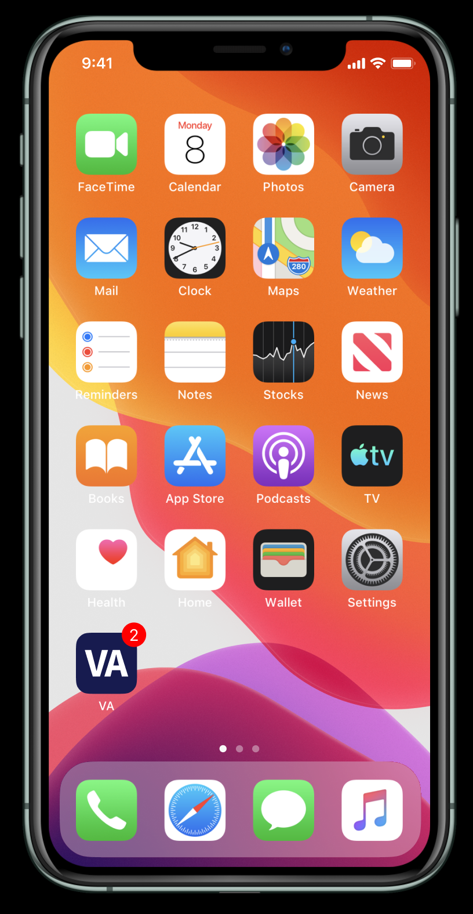

From here, we walked each Veteran through the login experience when opening their VA Mobile application. We told them that Kim Washington had an ID.me account and had Face ID enabled, see Figure 2.

#### Figure 2

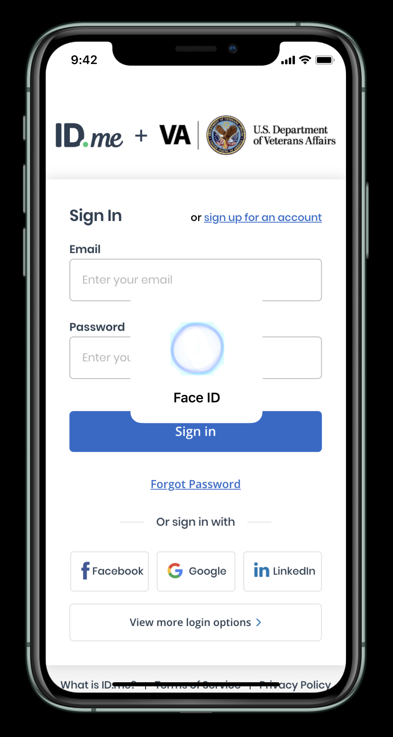

After receiving feedback on the login experience, we stopped at a specific “loading” screen and asked participants what they would expect after logging in to their VA mobile app. They were then brought to a home screen for Kim Washington, with specific information pertaining to her account, see Figure 3.

#### Figure 3

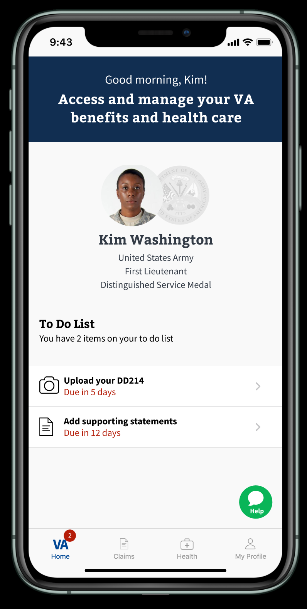

We then had participants walk through the experience of uploading a specific document (DD214) to their VA Mobile app. We purposefully left it open ended as to what the upload was for so that we could get their feedback on expectations, see Figure 4.1 and 4.2.

#### Figure 4.1

#### Figure 4.2

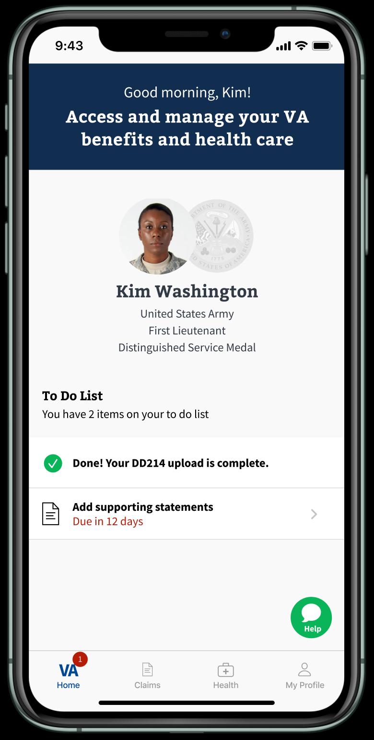

We then walked participants through a possible approach to a claims list view on VA Mobile and asked them specific questions around this layout, such as what they thought “Filter” meant in this context. These questions helped to gain an understanding of what they would hope and expect to see on this tab in a VA mobile experience, see Figure 5.

#### Figure 5

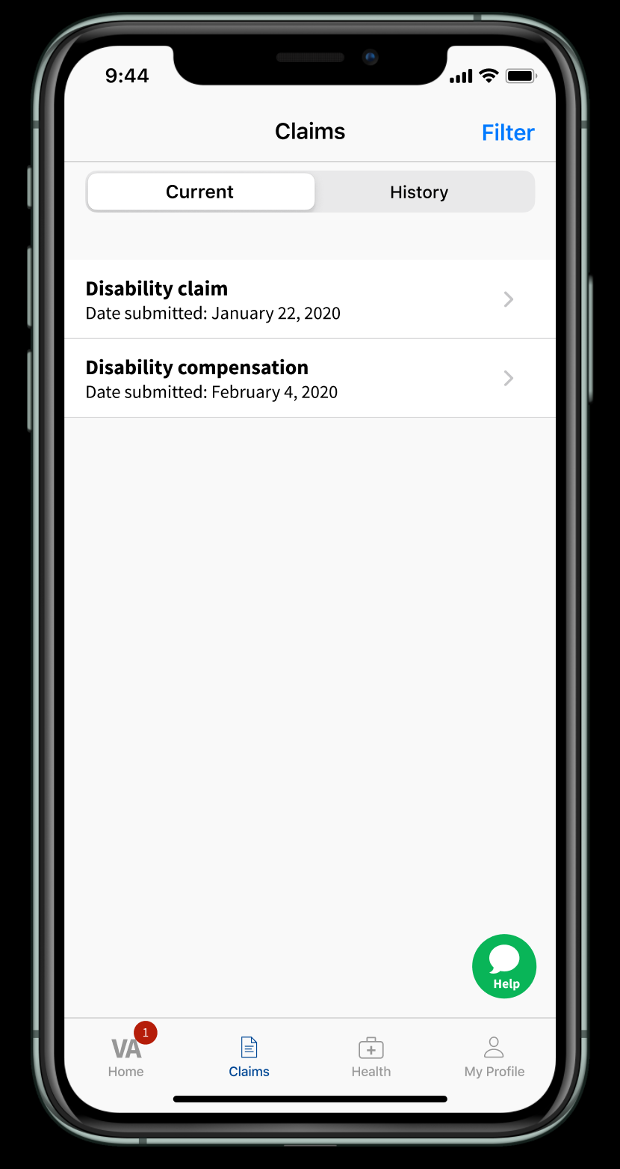

For the final task, we walked through a possible approach to a mobile “VA Help Desk” experience, see Figure 6.

#### Figure 6

